The Arunachal Times

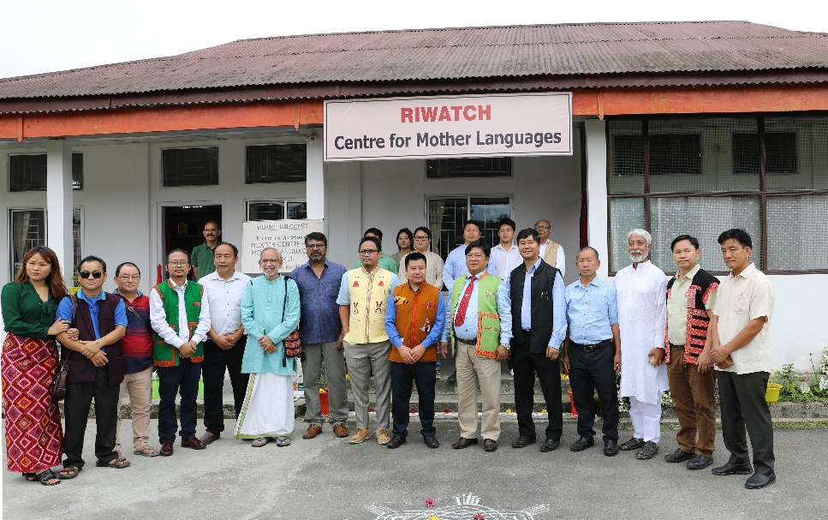
May 28, 2023
KHINJILI, 27 May: The RIWATCH Centre for Mother Languages (RCML) – a dedicated centre aimed at preserving and promoting linguistic diversity – was inaugurated here in Lower Dibang Valley district by Pasighat (East Siang)-based Arunachal State University Vice Chancellor Prof. Tomo Riba and Indigenous Affairs Director Sokhep Kri, in the presence of Idu-Mishmi Cultural & Literary Society (IMCLS) President Dr. Ista Pulu, RIWATCH academic adviser Padmashree Satyanarayan Mundayoor, and others on Saturday.
The centre is supported by the North Eastern Council and the state’s indigenous affairs department.
Prof. Tomo Riba in his inaugural address said that children should be taught to “listen more to learn and understand their mother languages,” and added that “people’s willingness to speak is a major factor to save and transmit one’s dialect/language to new generations.”
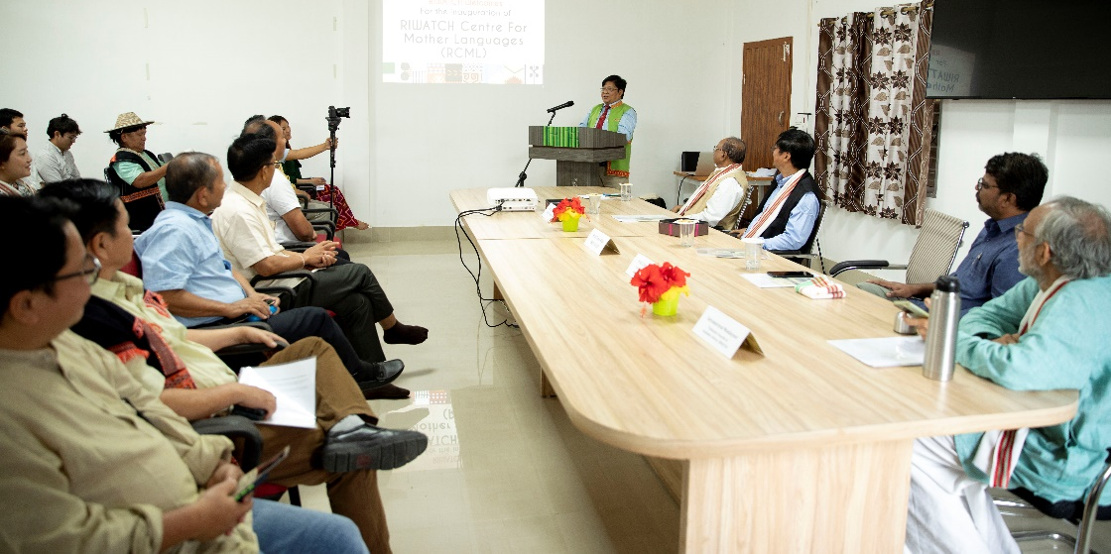
Kri in his address said that “the bigger responsibility lies with communities to take forward the steps to promote and preserve their mother tongues.”
Speaking on the wide array of initiatives of the indigenous affairs department, he said that “a centre like RCML is just a beginning towards mother tongue documentation and preservation in Arunachal Pradesh.”
Mundayoor in his address stressed on “development of speaking skills among children to better learn their mother languages.” He said also that there is a need to initiate “bilingualism as a mass movement in schools, colleges, universities, government offices, etc, to make people learn multiple languages simultaneously.”
Doimukh-based Rajiv Gandhi University’s Centre for Endangered Languages (CFEL) coordinator Prof. S. Simon John said that “Mother tongue is ascribed and gives identity to native speakers, and centres like RCML can be a harbinger for promoting and preserving one’s identity through research and documentation.”
CFEL assistant coordinator Dr. Lisa Lomdak stressed on “greater community engagement for the development of pedagogy materials for children in native dialects/languages,” and added that the RCML “can be an avenue for collaborative projects for developing children’s literature.”
IMCLS President Dr. Pulu and RIWATCH Executive Director Vijay Swami also spoke.
Later, an MoU for collaborative projects and publications was signed between the IMCLS and the RMCL.

