Outreach prog on mother tongues organised
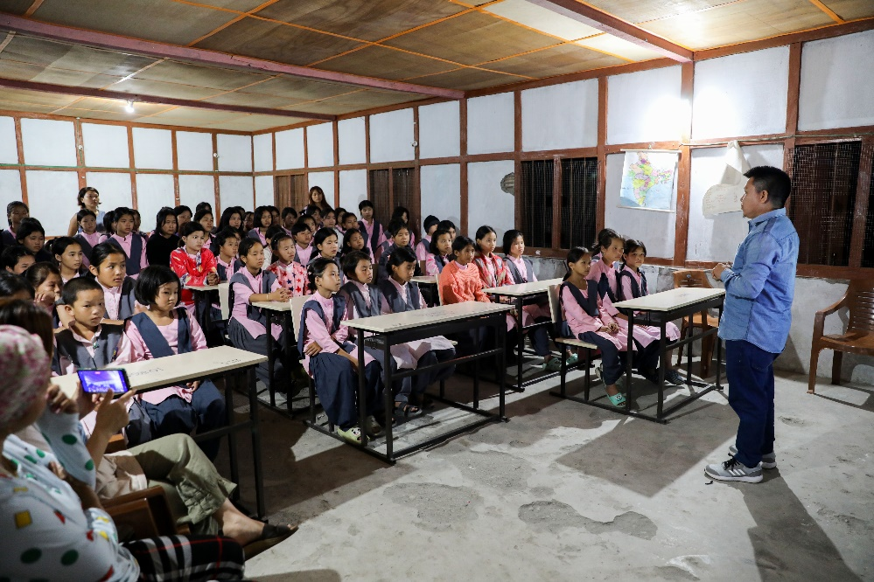
June 27, 2023

HUNLI, 26 Jun: An outreach programme themed ‘Awareness of mother tongues’ was conducted at the Kasturba Gandhi Balika Vidyalaya (KGBV) here in Lower Dibang Valley district on Monday by the RIWATCH Centre for Mother Languages (RCML) of the Research Institute of World’s Ancient Traditions, Cultures & Heritage (RIWATCH).
“The programme was part of the field research under the ongoing research project on ‘Documentation of cultures and languages of Arunachal Pradesh’, under the RCML, in collaboration with the North Eastern Council,” the RCML informed in a release.
A documentary film titled The Songs We Sing, The Drums We Beat, based on the Nocte culture and language, and directed by Dr. Kombong Darang, was screened during the programme for the students and teachers of the school.
RCML coordinator Dr Tame Ramya presented a brief on the activities of the RCML to promote and preserve the cultural and linguistic heritages of the tribal communities of Arunachal Pradesh.
“Although dominant languages like English and Hindi are important in this era of globalisation, one should still continue to learn and speak their own mother tongues, especially with family members and friends within and outside the school,” Ramya said, adding that “this will go a long way in keeping one’s mother tongue intact, and pave the way for its smooth transmission from one generation to the next.”
“The teachers, especially the native speakers, can be harbingers for the promotion of mother languages in schools. Schools should carry out activities based on mother languages, such as
storytelling competition, folksongs competition, story writing competition, etc, among the students, so that their mother languages remain intact with them,” he added.
KGBV Principal Rimi Linggi said that “there is a need for a parallel curriculum for promotion of mother languages in schools, along with English and Hindi.”

